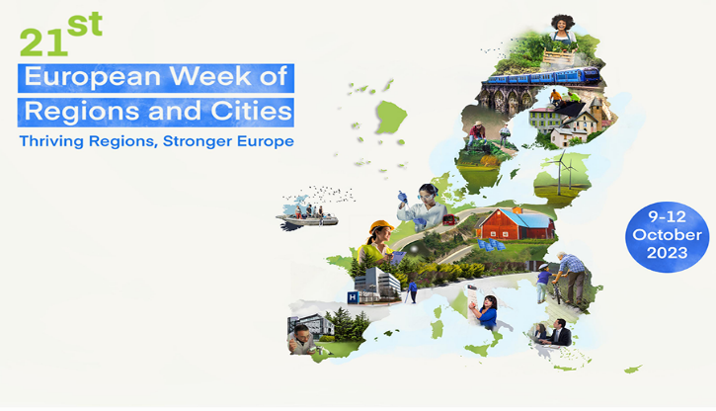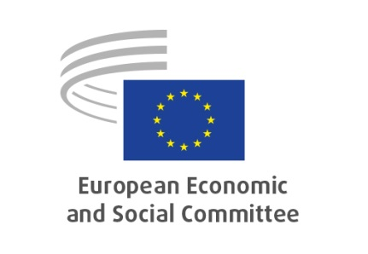**SECTION FOR ECONOMIC AND MONETARY UNION AND ECONOMIC AND SOCIAL COHESION (ECO)**

**POLITICAL LAB on**

***''Retaining talents and skills for regional growth. What is the role of civil society partners?''***

**11 October 2023, 16:30 - 18:00**

**_________**

**Venue: Rue Belliard 99-101 – 1040 Brussels**

**Meeting room: Atrium 5**

**Orientation key questions for debate:**

**How social and civic dialogue can be effectively used together to address the structural challenges in a local context, enhancing the regions' attractiveness for talents? Could you provide a concrete example or an idea of/for such a cooperation? (Responsible:** **Tatjana BABRAUSKIENĖ)**

**The 8th Cohesion Report have shown that there are still a lot of EU regions that face development traps and demographic challenges which lead to bigger unemployment and loss of the remaining workforce. How regions can reverse the situation? Which are important steps forward? If you have to choose one concrete policy of retaining the talents and boost growth, which should it be? (Responsible: Christian Spahr)**

**How can research and innovation contribute to regional development policies, and support regions that are facing a talent-trap and braindrain? (Responsible: Astrid Hannes)**