Regional Partnership: Providing the right skills for a water-smart society

The session dived into the importance of preparing the water sector for the twin transition, while at the same time finding an answer to the ageing workforce and the impact of climate change, which highly affect the availability of clean freshwater sources.

UN Water Conference
March 2023 the 2nd UN Water Conference took place in New York city. UN Secretary-General António Guterres stated in his closing remarks:
- “This conference demonstrated a central truth. As humanity’s most precious global common good, water unites us all. And it flows across a number of global challenges.
- Water is about health, sanitation, hygiene and disease-prevention. Water is about peace. Water is about human rights and gender equality.
- All of humanity’s hopes for the future depend, in some way, on charting a new science-based course to bring the Water Action Agenda to life. They depend on realizing the game-changing, inclusive and action-oriented commitments made by Member States and others at this Conference.”
The UN Water Conference asked for concrete water actions. During the EWRC2023 three regions established a regional partnership to support the next generation of water professionals in the framework of the European Year of Skills.

EU Blue Deal
October 27th 2023 the EESC Plenary adopted the “umbrella” opinion to call a comprehensive EU Water Policy. The document is titled: EUBlueDeal. In addition, they also adopted a declaration addressing political Pillars and key Actions needed.
The session started by Pedro Angosto introducing how water challenges are addressed in a regional context. Majbritt Lund added how VIA University College contributes to develop a new curriculum addressing the needs of water utilities. Marianne Poelman shared how the province of Friesland has worked on vocational excellence over the past decade and how to prepare VET students for the twin transition. The session was chaired by Isabel Ladron arroyo, policy officer green skills at DG Employment.

Region of Murcia
Pedro Angosto, Director, Cifea de Molina de Segura y CRN en Industria Alimentaria
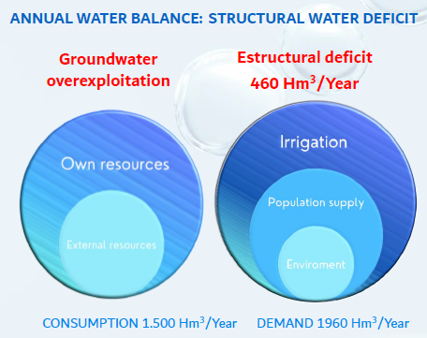
The Region of Murcia in Spain has a semi-arid Mediterranean climate, with average year-round temperatures above 18ºC and a very low rainfall rate of around 250 mm per year . On the other hand, two of the basic pillars on which the regional economy is based are agriculture and the agri-food industry. These 2 situations result in the region having a structural water deficit in an annual balance/basis: we dispose of 1500Hm3/year counting with both own resources and external resources but the water demands of our economy rise up to 1960 Hm3 /year taking into account the needs for irrigation, pupulation supply and the environment. This translates into a yearly structural deficit of 460 Hm3 of water.
In this context, the challenge the Region of Murcia is facing regarding water is to achieve efficiency in water management through high technology. This challenge can be divided in 4 sub-challenges:
- High irrigation efficiency based on
  - Strong presence of localized irrigation techniques.
  - The efficiency of our irrigation water is the highest in Spain.
  - Strong investment in the restructuring and modernization of irrigation system.
  - Water is paid by the farmers, the most expensive in Spain.
- Water reusing. The Region of Murcia is considered the region with the most and best wastewater treatment in Spain.
  - Reuse over 100 Hm3/year water, accounting for 25% of all Spain.
  - 99% of the urban population of the Murcia region is connected to the sewerage system and 95% at a treatment plant.
  - We apply the highest purification technology (tertiary systems).
- Seawater desalination
  - Spain is the world's fourth largest producer of desalinated water.
  - Murcia: 139 Hm3/year - 9% of annual water use.
  - Working on improving energy efficiency.
- Hydro efficiency in the food industry
  - Knowing the company’s water footprint.
  - Reduce consumption.
  - Hygienic eco-design in cleaning equipment.
  - Reducing pollutant loads.
  - Reuse of wastewater.

What is the solution the Region of Murcia proposes for this challenge? Upskilling the water ecosystem, boosting the innovation critical mass, through the close collaboration of the water ecosystem actors with the knowledge-generating institutions. Our region’s approach:
- Identifying the problems or needs: Research
- Technology transfer
- Training people
Here we present a panoramic “photograph” of our regional water ecosystem key actors, with the Regional Ministry for water, agriculture, livestock and fisheries at its core:

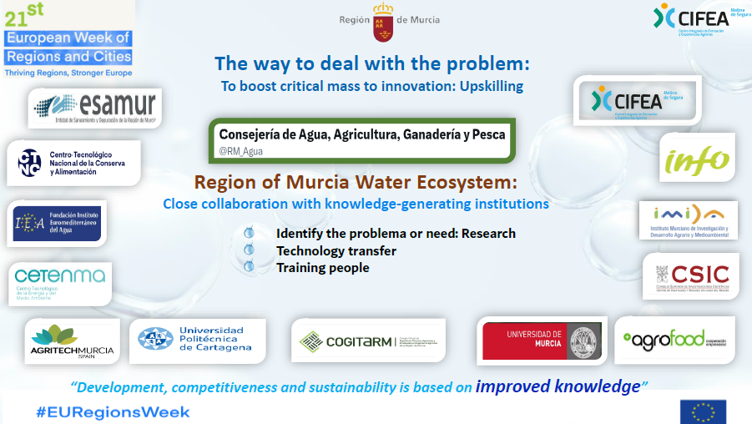

One of the clearest examples of the Region of Murcia’s efforts to upskill its water sector is CIFEA’s activity. CIFEA is a public VET institution (Integrated Centre of Vocational Training) offering trainings in the fields of agriculture, water management, food processing, environment and gardening, as well as actions of transfer of technology. It is:
- a Centre of Excellence in VET – a catalyst institution in the design of an innovative ecosystem for vocational training.
- A national reference centre for the VET system – aims to facilitate the competitiveness and quality of the VET system, and make it respond to the changes in demand of qualifications in the productive sectors.

CIFEA is also involved in actions of recognition, evaluation and accreditation of professional competences, international training and innovation projects and international development cooperation projects.

Central Denmark Region
Majbritt Lund, Representative, VIA University College
Key takeaways from the Central Denmark region:
- Continuing Education Challenge: The challenge presented by Majbritt Lund relates to continuing education for a water-smart society. The lighthouse project (a Danish consortium bringing together both private and public stakeholders in the water sector) conducted an educational overview, revealing a need for specialized continuing education in the water sector. The mapping showed a significant gap in possibilities for continuing education, particularly in domains like digitalization and sustainability in the rapidly evolving water sector. This need is recognized not only in Denmark but also across the EU.
- Designing Continuing Education and SWAT: The presentation discussed the design of continuing education, particularly an online course named "School of Water and Applied Water Technologies (SWAT)." The course was designed to equip staff in the Danish water sector with the skills necessary for lifelong and flexible development, enabling them to adapt to changing contexts at all employee levels. The aim was to emphasize the need for a profound focus on continuing education within the water sector workforce to develop water-smart society skills.
  - If more SWAT is needed: SWAT Online Course: The SWAT online course is a 6-week program designed for operators of daily routines in drinking water treatment processes in Denmark.
  - Course Development: The course combines online self-study with online workshops and was developed in close collaboration with utilities to address real-world challenges.
  - Course Content: It includes visual content such as video-recorded interviews, virtual field trips, mini-lectures, and data-sharing.
  - Online Workshops: Four online workshops with group discussions and knowledge sharing were included in the course.
  - Participants: The course attracted a mix of operators and project managers from small and large waterworks.
- Positive Feedback from SWAT: Participants found the online format convenient, and some used the course as a starting point for discussions on their operational routines. Those who completed the course received an official course certificate, aligning the online course with formal courses. There is a request for follow-up courses that focus on more specialized water technology topics.
- Elements from the panel discussion: To ensure the workflow of adequate skills needed in the water sector, a European framework of transferability of skills must be strengthened. Isabel highlighted micro-credentials as an important instrument in this regard. Perhaps this forms the basis of a future Erasmus+ collaboration.

Municipality of Southwest Friesland
Marianne Poelman, Deputy Mayor, Municipality of Southwest Friesland
In 2014 Peet Ferwerda and Marianne Poelman defined the regional need for future craftsmanship. Besides technological requirements, the future of craftsmanship needs to prepare VET students to become more pro-active, self-learning and agile. Technological and societal changes occur so rapidly that students need a new skill set to prepare them for the future.
This process coincided with the establishment of the Centre of Innovative Craftsmanship Water (CIV-Water) on the WaterCampus in Leeuwarden. This unique location offered VET the opportunity to be better embedded in the water innovation ecosystem. In close collaboration with companies and the water sector a curriculum for future water technicians was designed and annually updated. Also VET students can work side by side with BSc students in the experimental hall of the Water Application Centre. This also provided the right ingredients to initiate the Platform of Centers of Vocational Excellence in the ERASMUS programme.
Today CIV-Water is the coordinator of the PoVE Water Vocational Excellence project, which involved twenty-three partners from Europe and South-Africa.
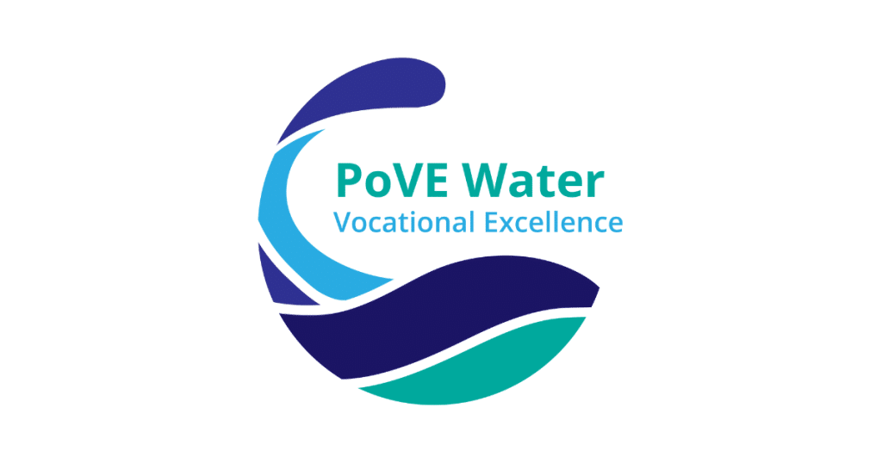
PoVE Water operates in a society in transition, where values such as sustainability, corporate responsibility and social value creation are becoming increasingly important.
This development goes hand in hand with trends in the water sector labour market. The sustainable availability of people and the utilisation and further development of available talent are becoming central.

A rapidly changing world
We need to deal with a rapidly changing world. Global warming has caused serious changes to the planet and are very often water related, such as rising sea levels and extreme weather events. But also think about an aging population and the effects on the labour market.

Excellent Water sector professionals
There is a vast need for Vocational Excellence and excellent Water sector professionals. Vocationally educated water sector professionals are the operators in the field that work directly with water resources of Europe and have, when educated appropriately as circular economy ambassadors, the power to contribute directly to the transition towards a reformative growth model that gives back to the planet more than it takes.

VET in Regional Innovation Ecosystems
We need a central position for Vocational Education and Training (VET) in Regional Innovation Ecosystems. When truly having VET in an operational position on board of the innovation ecosystems, they will act as an extra sensor for spotting opportunities for cooperation and solutions in Europe.
There is room for more European cooperation and this event will form an important step in that process.
In her address Marianne Poelman emphasised the need for an agile workforce and to showcase what opportunities the youth has in the water sector. Many children are unaware of the possibility of starting a career in the water sector.

Water Smart Society
Water Europe advocates a Water-Smart Society, which is a society where:
- the true value of water is recognised and realised,
- all available water sources are managed in such a way that water scarcity and pollution of water resources are avoided,
- water and resource loops are largely closed to foster a circular economy and optimal resource efficiency,
- the water system is resilient against the impact of climate change events,
- all relevant stakeholders are involved in the governance of our water system.
The three regions involved in this partnership have various running initiatives which aim for these same outcomes, with reducing pollution, unlocking the circular economy (for water, nutrients and other resources in water) and addressing climate change as some of the main focus areas.

European water utilities seek more water operators
EUREAU and Aqua Publica Europea also highlighted the need for additional talent in the water sector. The average age of employees in water utilities is very high. There will be a high rate of replacement needed in the coming years. In addition, the twin transition and adaptation to climate change will require new talent to work with novel technologies.
Currently the inflow of students into relevant education programmes is too low. There is a high need for more awareness and a campaign to make working in the water sector more attractive. When people would know how working in the water sector truly looks like and what impact you have on society it should be easy to gain more interest from the current generation of students, which are all very aware about the effects of climate change. Working in the water sector would be a way to contribute to society in a positive way.

