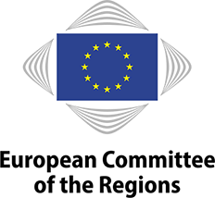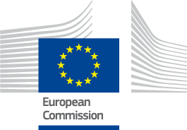

**EUROPEAN WEEK OF REGIONS AND CITIES – PANEL DEBATE**

**The role of cities in the 100 Climate-Neutral and Smart Cities mission (100CNSC)**

Jacques Delors building, JDE 53 (Brussels)

Round table with high representatives of Madrid, Vilnius, Lódz and The Hague, four cities that are part of 100Climate-Neutral and Smart Cities Mission (CNSC).

They will share their cities experiences and strategies on this topic, in a panel moderated by Kirsten Dunlop, KIC Climate CEO.

Three of the panelists are members of the European Committee of the Regions.

**16:30 Welcome and introductory remarks**

* Kirsten DUNLOP, KIC Climate CEO

**16:38 Panel – debate**

* José Luis MARTINEZ-ALMEIDA, Mayor of Madrid (Spain)
* Valdas BENKUSKAS, Mayor of Vilnius (Lithuania)
* Hanna ZDANOWSKA, Mayor of Lódz (Poland)
* Arjen KAPTEIJNS, Deputy Mayor of The Hague (The Netherlands)

**17:10 Q&A**

**17:00 End of session**