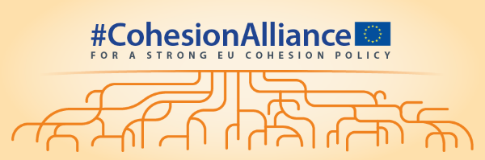
No future of cohesion without representation!
Wednesday 15.10.2025
14.30 – 16.00
European Committee of the Regions (Room JDE 52)
Languages available: EN FR DE IT ES PL
Draft agenda - version 13.10.2025

The event is preceded by a 'call for action event' at the European Parliament esplanade from 13.45 to call for a future Cohesion Policy with full partnership rights for local and regional authorities and to oppose its nationalisation and centralisation

Together with representatives of major European associations of local and regional authorities, the European Committee of the Regions is fully mobilised to make its voice heard as part of the ongoing debate on the future of Cohesion policy for the 2028-2034 period.

Building on the work realized over the past three years and the joint call to the to the European institutions and national governments to keep Cohesion Policy at the core of the EU's development model in the next decade adopted at the 10th European Summit of Regions and Cities in March 2024, this event marks a new mobilisation phase for those who believe in a stronger Cohesion policy which truly puts regions and cities at the center.

It provides a clear opportunity for presidents of the major European associations of local and regional authorities:
- to assess jointly the new proposals issued on 16 July on the future of Cohesion policy as part of the Multiannual Financial Framework package for 2028-2034
- to agree on a common vision to ensure that Cohesion Policy emerges reinforced as a decentralized investment policy for all regions at the outset of the interinstitutional negotiations
- to discuss future cooperation opportunities and joint actions in the framework of the Cohesion Alliance

At the occasion of the event, Cohesion Alliance partners will adopt a joint call for action for a revision of the MFF proposals in favour of a reinforced Cohesion policy for all regions in the future.

DRAFT AGENDA

Moderator of the event: Merle Becker

Speakers:
- Kata TÜTTŐ , President of the European Committee of the Regions
- Joris BENGEVOORD, President of the Association of European Border Regions (AEBR)
- Lilijana MADJAR, Vice-President of the Assembly of European Regions (AER)
- Christoph SCHNAUDIGEL, Co-President of the Council of European Municipalities and Regions (CEMR)
- Filip REINHAG, President of the Conference of Peripheral Maritime Regions (CPMR)
- Anna Lisa BONI, Deputy Mayor of Bologna (EUROCITIES)

14.30: Introduction and presentation of the event by Merle Becker (moderator)

14.35: First roundtable discussion - Assessing the proposal of the European Commission on the future Cohesion Policy

Published on 16 July 2025 as part of a broader package on the 2028-2034 multiannual financial framework, the proposals of the European Commission on the future of Cohesion Policy include radical changes for the policy. By proposing national and regional partnership plans, the proposals call into question the traditional role of Cohesion Policy as a long-term and decentralised investment policy for all regions. How do the proposals of the Commission differ from the vision of Cohesion Alliance partners on the future of Cohesion Policy?

15.05: Second roundtable discussion - Building common messages for the future

Negotiations on the post-2027 multiannual financial framework, including concerning Cohesion Policy, are well underway. What are the key messages of the Cohesion Alliance partners to ensure that the future Cohesion Policy emerges reinforced as a long term and decentralized investment tool for all regions in the 2028-2034 period?

15.35: Third roundtable discussion - A new mobilisation phase for the Cohesion Alliance – Presentation of the joint call for action

Building on the common assessment of the Cohesion Alliance partners on the Commission proposal about what is missing in the Commission proposal on the future of Cohesion Policy, and how it should be changed so it stays true to its Treaty objectives, how should the Cohesion Alliance work together in the coming months ahead?

15.55: Final word by Kata TÜTTŐ, President of the European Committee of the Regions

16.00: Closing

